SPORTS AND GAMES
Report for the academic year 2018-19
Our college has participated in Kerala Technological University inter collegiate tournaments.
- Kabbadi men’s team won first place in B zone held at MES College.
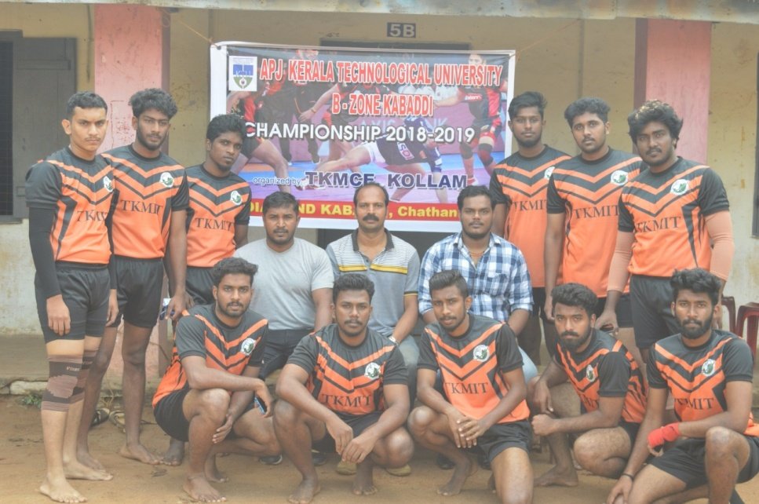

- Women’s basketball women’s team won second place in B zone held at our college.
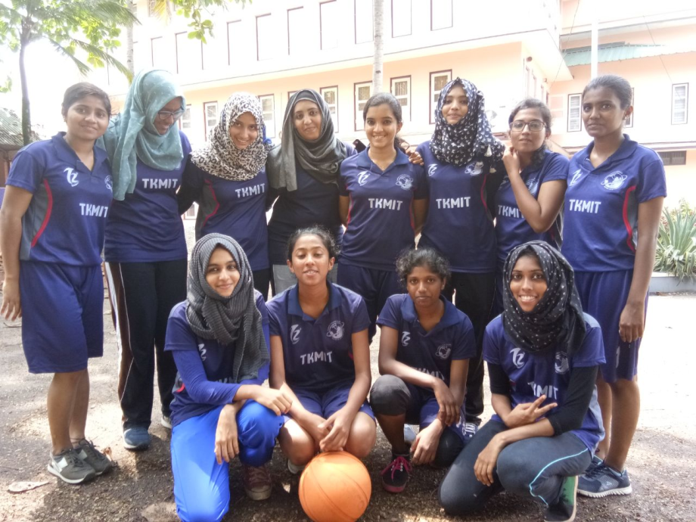

- College team participated in cricket men’s tournament held at TKM College of engineering organized by APJAKTU B ZONE.
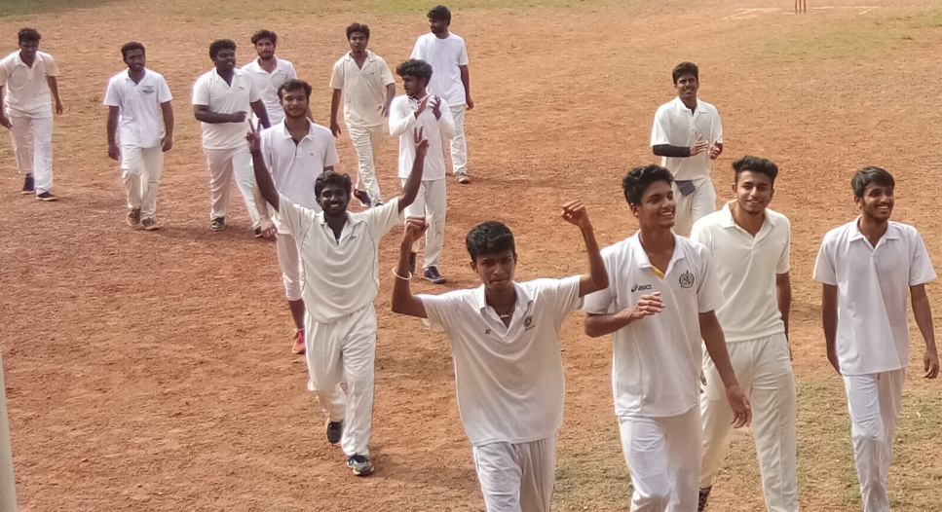

- College team participated in football men’s tournament held at YIT organized by APJAKTU B ZONE.
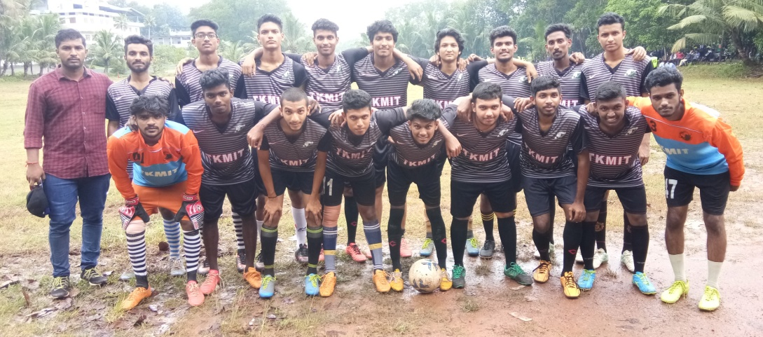
- College team participated in basketball men’s tournament held at BISHOP JEROME College of engineering organized by APJAKTU B ZONE.

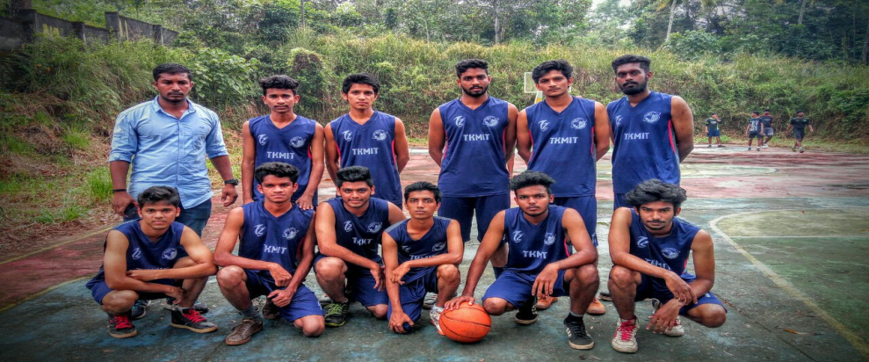

- College team participated in chess men’s tournament held at BISHOP JEROME College of engineering organized by APJAKTU B ZONE.

- College team participated in badminton men’s tournament held at TKM College of engineering organized by APJAKTU B ZONE

- College team participated in volleyball men’s tournament held at TKM College of engineering organized by APJAKTU B ZONE

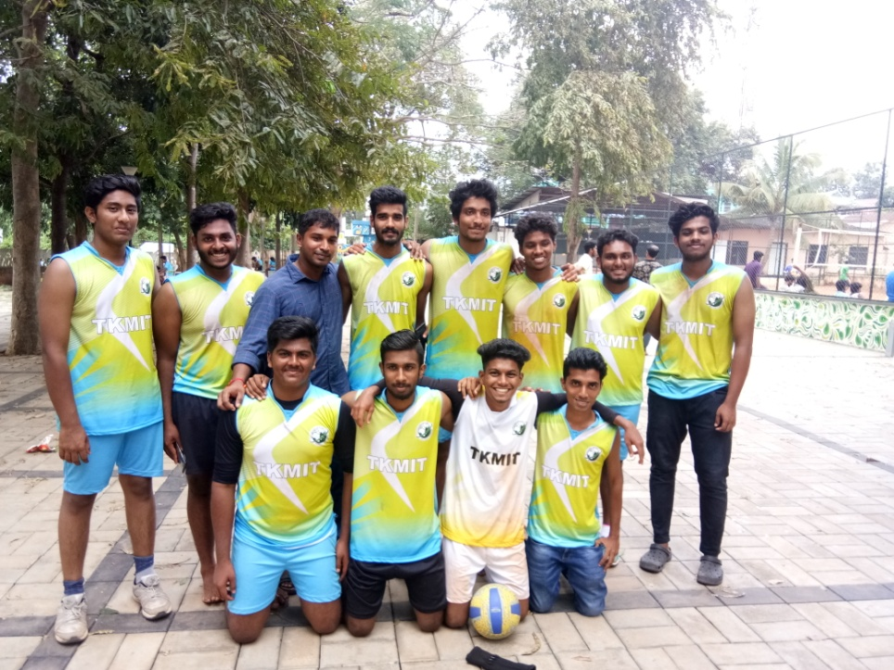
.
- Our sports day and athletics meet was held from 11/03/ 2019 to 16 /03/2019
Games along with their categories are as follows:
- Volleyball (men)
- Cricket (men)
- Football (men)
- Badminton (men and women)
- Basketball (men and women)
Our college sports day was celebrated on 16/03/2020.
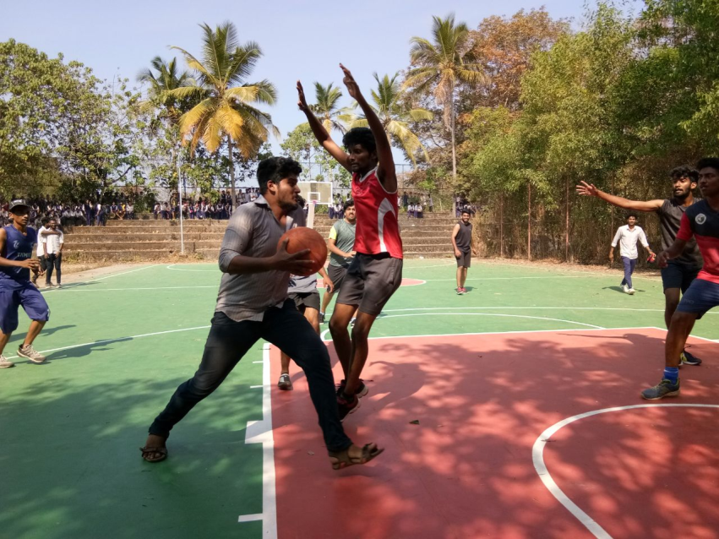
Overall first position was won by dept: of food technology.

